CS4335 Tutorial Week 3

Question 1: Use Kruskal’s algorithm to find a MST for the following graph.
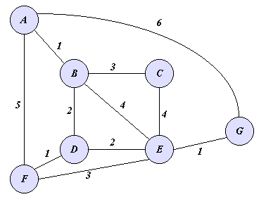

(A,B) (E,G) (D,F) (B,D) (D,E) (B,C)
1 1 1 2 2 3

Question 2. Use Prim’s algorithm to compute a MST for the above graph.

A B C D E F G
Key: 0 + + + + + +
Parent: nil nil nil nil nil nil nil
Key: 1 + + + 5 6
Parent: A nil nil nil A A
Key: + + + 5 6
Parent: nil nil nil A A print(B,A)1
Key: 3 2 4 5 6
Parent: B B B A A print(D,B)2
Key: 3 2 1 6
Parent: B D D A print(F,D)1
Key: 3 2 6
Parent: B D A print(E,D)2
Key: 3 1
Parent: B E print(F,E)1
Key: 3
Parent: B print(C,B)3

